Exercise 7
Web Automation Testing using Selenium

Aim
To automate browser actions and perform a basic functional test using Selenium.

Software Required
- Python
- Selenium
- Chrome/Edge browser
- PyCharm or VS Code

Installation
pip install selenium

Code
from selenium import webdriver
from selenium.webdriver.common.by import By
driver = webdriver.Chrome()
try:
driver.get("https://www.google.com")
print("Page title:", driver.title)
search = driver.find_element(By.NAME, "q")
search.send_keys("Software Engineering")
search.submit()
print("Search test completed.")
finally:
driver.quit()

Procedure
- Install Selenium using pip.
- Ensure Chrome/Edge is installed.
- Create selenium_test.py.
- Enter the program.
- Run the program.
- Observe the browser opening automatically.
- Verify that the search action is performed.
- Confirm that the browser closes in the finally block.
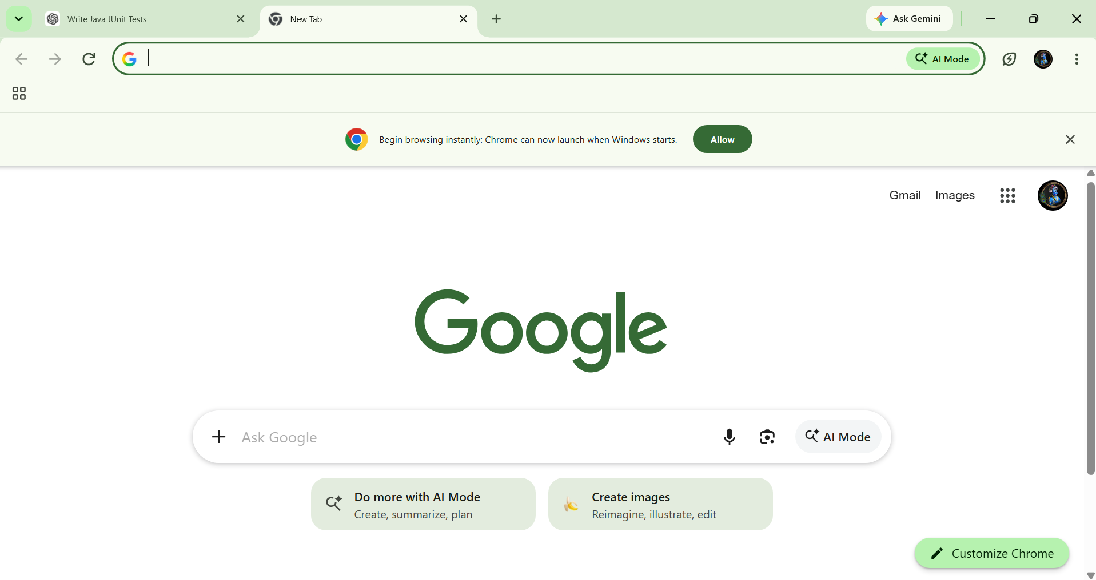

Result
Thus the experiment was successfully performed and the expected result was obtained.

